***Aura Econe Time Watch***

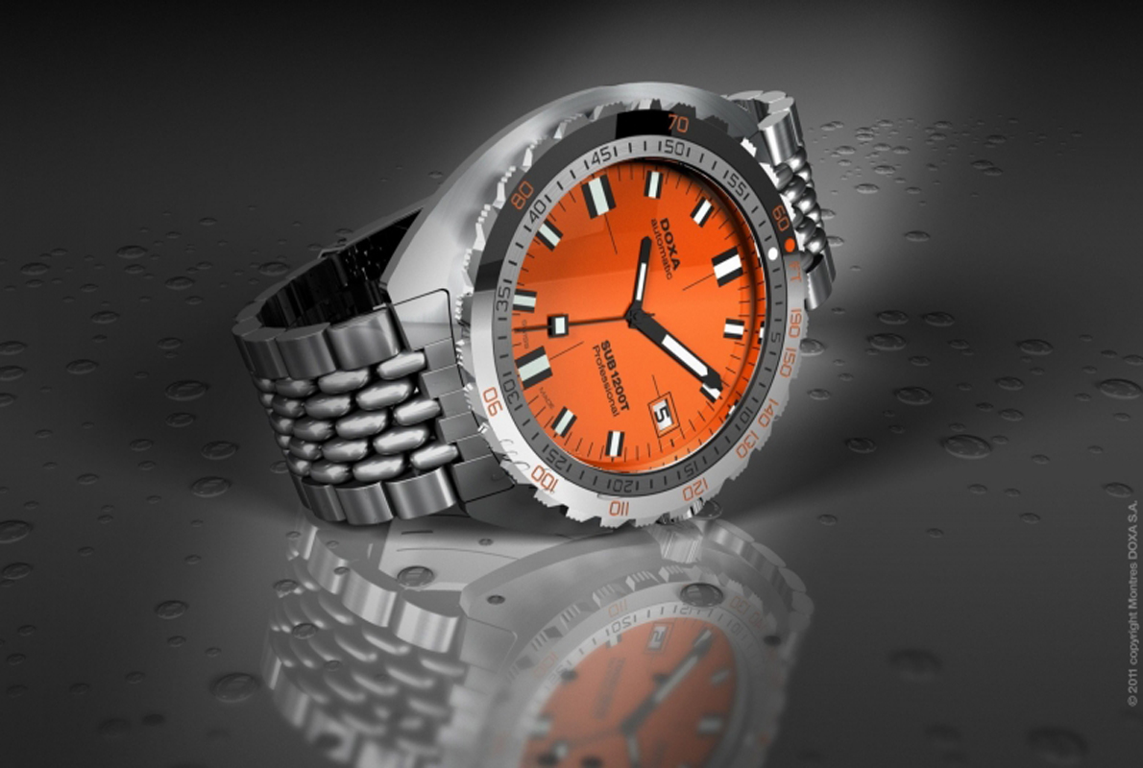

***DETAILS ABOUT THIS WATCH***

Case: stainless steel  
Face: ceramicMovement: Ronda quartz movement with Swiss parts  
Dimensions: 40 mm diameter / 11.5 mm thickness  
Fit: adjustable buckle with holes fits wrists 6 ¼ – 8 ½ inches (159 – 215 mm) in circumference, 20 mm strap width  
Water & Shock Resistance: The Bradley will easily withstand brief contact with water, like getting cell

***SPACES***

**DIAL COLOR:**Orange

**CASE SIZE:**40mm

***Price:***

***Rs:4,000***